

Model: ARC-57VA
Key Features
• 2MP Full HD Resolution  • H.265 Video Compression  • 45m IR Night Vision  • 3.6mm Fixed Lens  • Built-in Microphone  • IP67 Weatherproof & Metal Body | 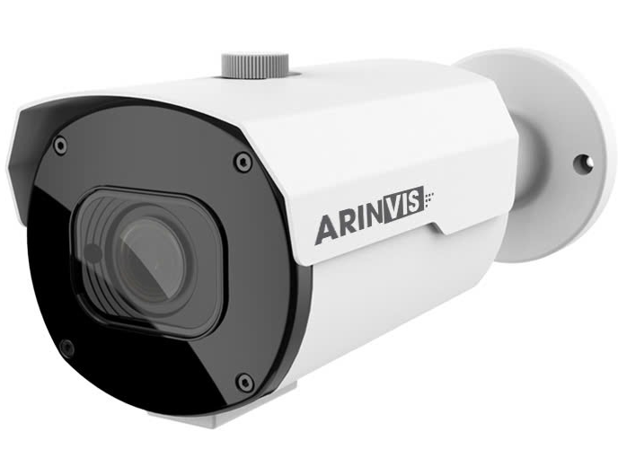
Camera Specifications

Video
Imaging Device | 1/2.7"
Effective Pixels | 2MP 1920(H)×1080(V)
Scanning System | Progressive CMOS
Min. Illumination | Color 0.006lux @ F1.6(AGC ON) ; B/W 0 lux @ IR ON
Lens Type
Focal Length (Zoom Ratio) | 3.6mm
Max. Aperture Ratio | F No. 2.2
Angular Field of View | Horizontal: 86°, Vertical: 47°, Diagonal: 105°
Min. Object Distance | 2m
Lens Type | Fixed(M12)
Operational
IR Viewable Length | Up to 45m
Camera Title | On/Off
Day & Night | IR cut filter with auto switch（Day/Night/Auto/Image/Schedule）
Backlight Compensation | Off/On (5 Zone)
Wide Dynamic Range | DWDR
Digital Noise Reduction | 3D DNR
Motion Detection | Off/On (8 Level)
Privacy Masking | Off/On (4 Zone, Rectangle)
Gain Control | Auto
White Balance | Auto/Manual
Electronic Shutter Speed | 1/5 ~ 1/20000s
On-Board Storage | Micro SD slot, up to 256GB
Alarm | NA
Audio | Built-in microphone
Hardware Reset | Yes
Smart Feature | NA
Network
Ethernet | RJ45(10/100BASE-T)
Video Compression Format | H.265/H.264
Resolution | Main Stream &30fps  1080P(1920x1080)  Sub Steam &20fps  VGA(640x480)
Video Quality Adjustment | 256Kbps ~ 4Mbps
Bitrate control method | CBR/VBR
Streaming Capability | Dual-Stream(Main/Sub)
Protocol | TCP/IP,HTTP,DHCP,DNS,DDNS,RTP/RTSP,  SMTP,NTP,UPnP,SNMP,HTTPS,FTP
Web browser | IE10/11
Security | complicated password;Authenticated username and password
Streaming Method | Unicast/Multicast
Application Programming Interface | ONVIF
Environmental
Operating Conditions | -35～+60°C/less than ≤ 90% RH
Ingress Protection | IP67
Electrical
Input Voltage / Current | D12V/POE(IEEE802.3af)
Power Consumption（IR OFF) | 2.5W-3.5W
Power Consumption（IR ON） | 6.5W-8.5W
Mechanical
Material | Metal
Dimensions (HxWxD) | 242*87.4*83.88mm
Weight | 811g

Dimension
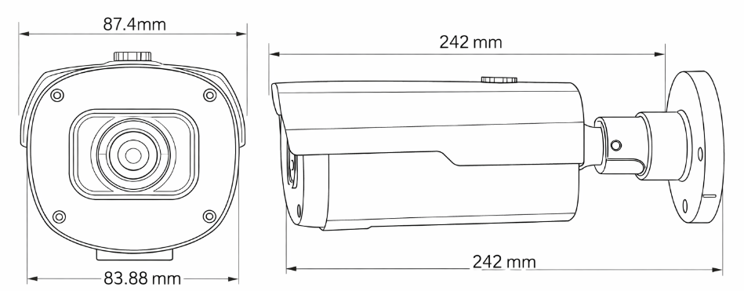

Accessory

